**26/10/2021 CD SPOT 7 2019103573**

**SPOT – EXERCISE**

**1.To write a program to convert the given postfix expression to infix expression.**

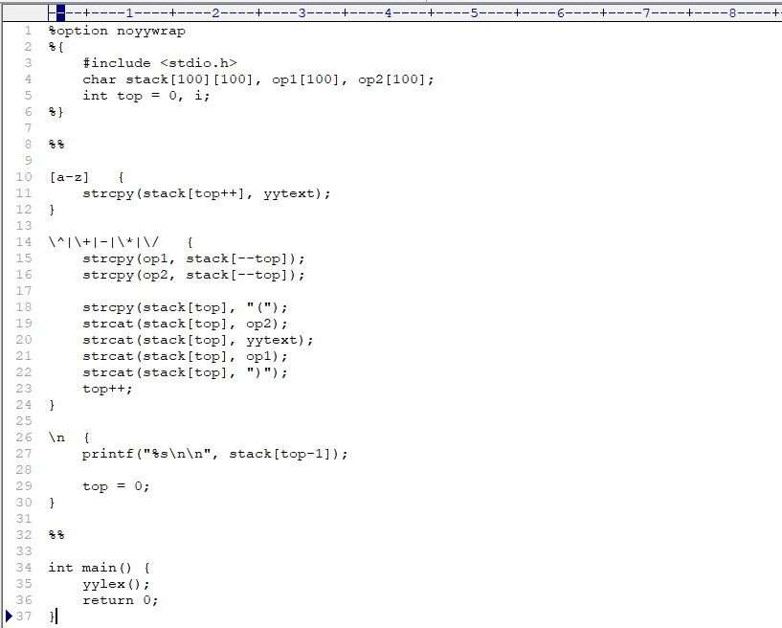**CODE :-**

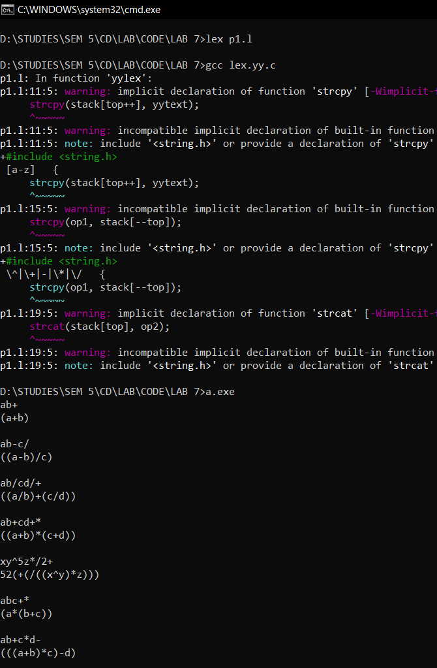**OUTPUT :-**

**2.Write a program to convert the given macro to function.**

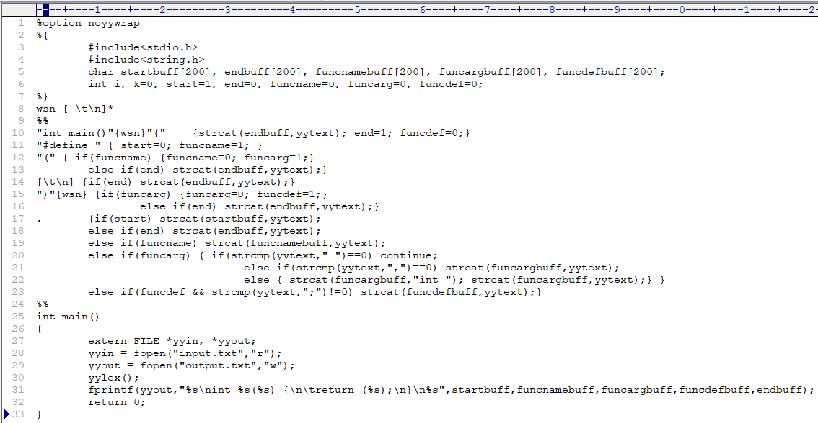**CODE :-**

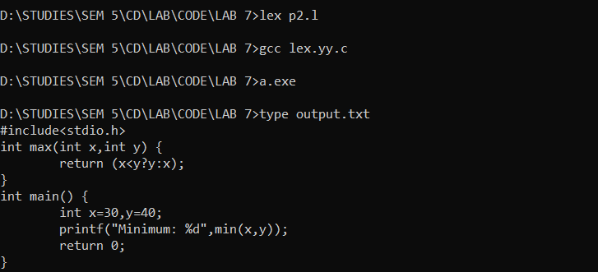**OUTPUT :-**

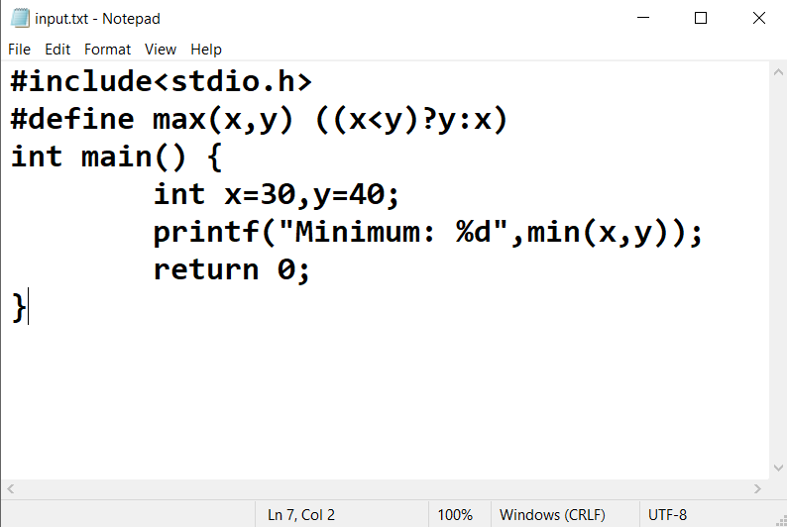**Input.txt**

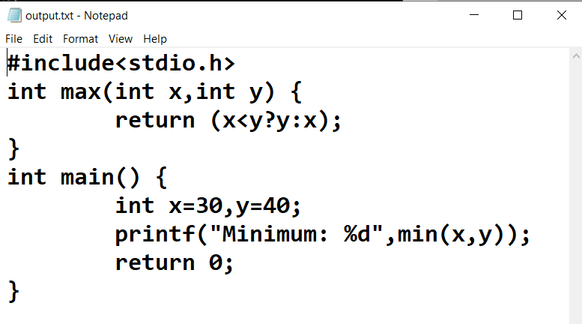**Output.txt**